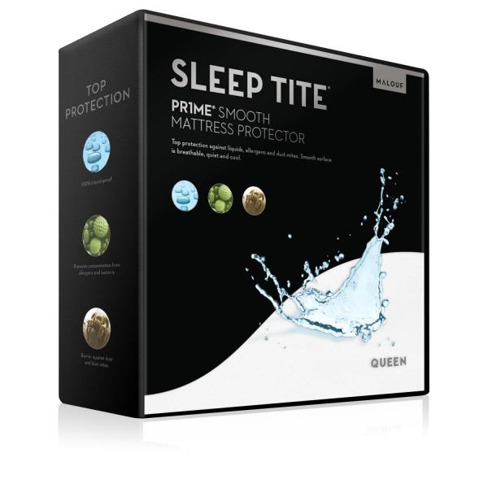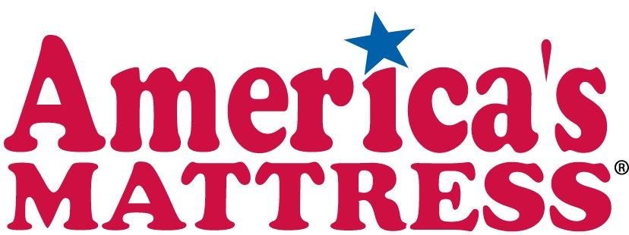

**2716 S College Ave, Suite A | Phone: (970)658-5950 | www.Americasmattress.com/Frontrange**

FREE

Mattress Protector-Malouf Sleep Tite PR1ME Smooth Mattress Protector

Valid until: 10/31/2017

**Coupon valid for purchases over $399.99 only. One coupon per customer. Must be redeemed at time of sale. No cash value. Item non-returnable.**