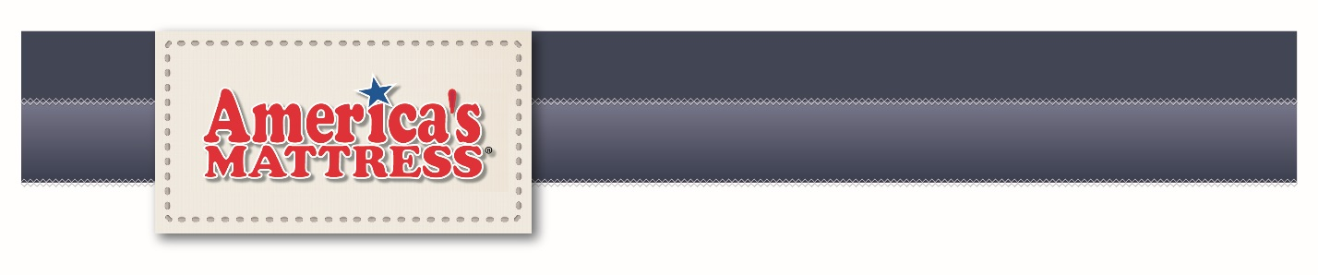

**TWO FREE MOVIE TICKETS**

For Cinema 8, Brookings, when you comfort test Serta iComfort.

**BONUS**

$100 Gift Certificate when you purchase any Serta Perfect Sleeper

Adjustable friendly mattress with a motion base.

Cannot be combined with any other offers or coupons.

Coupon has no cash value. One coupon per family/address.

**Coupon expires December 31, 2017**

See store for details